The importance of being a high school graduate in today’s society becomes more apparent every year. It is our goal at Maple Valley Schools that every student who enters our doors will earn a diploma. Unfortunately, we have some students who slip away from us before we even know it has happened. Luckily, we have a solution for this. Based on research from the University of Chicago, we now have tools to help us identify at-risk students before they even know they are on track to dropout. These tools are called Early Warning Indicators and they are as easy as knowing your ABC’s.
Maple Valley Schools
Maple Valley Schools

A - Attendance (Miss more than 10% in a semester)
B - Behavior (Out of school suspensions or expulsion)
C - Course Proficiency (Grade point average and failure in English or Math)

The University of Chicago found that students who had all three of these indicators present were 75% less likely to finish high school and earn their diploma. If possessing two indicators, regardless of which indicators they were, half of the students dropped out.

Maple Valley has used this approach to compile a list of 60 students who need our help; however, please know that students will come and go from this list. We feel attendance is the area we need to focus on right now.

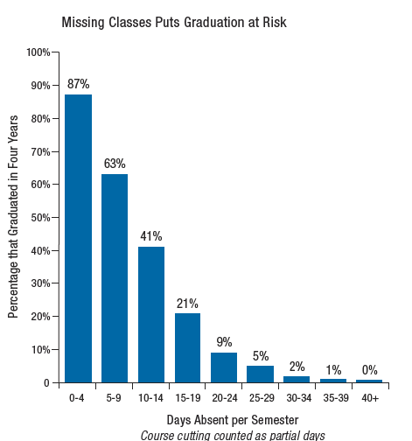
The following chart helps put the correlation between attendance and graduation into perspective. Nearly 90 percent of Freshman who miss less than a week of school per semester, regardless of how they did in junior high, will graduate in four years. On the other hand, when students missed two weeks in a semester graduation rates dropped to 25%. The University of Chicago did not find an impact on graduation rates if the absence was excused or not excused. Furthermore, the data showed no difference in student success whether the parent phoned in for the absences or not. Missing school for any reason means missing instruction and the learning that takes place that day.

Please help Maple Valley reach its goal and graduate every student who steps through our doors. We need parent and student support to get there. Please encourage and expect your child to attend school daily. It’s always better to try to attend school and go home at lunch than to not go at all. Parents, please book student appointments around school hours; however, we know that it is not always possible. It is in your child’s best interest to choose to send them back to school when the appointment is over. It is better to come to school for part of the day than to miss a whole day’s worth of content.

Thank you for your time,

Todd Gonser

